TOWN OF CARLTON LANDING
SPECIAL MEETING OF THE BOARD OF TRUSTEES

Location: 10B Boulevard, Carlton Landing, Oklahoma, also known as
the “High School Classroom”
Sunday; September 23, 2018; 11:30 AM

MINUTES

1. Call to Order

The meeting was called to order at 11:34 a.m. with Mayor Chinnici presiding.

2. Roll Call

PRESENT: A roll call reflected that Trustees Chinnici, Carrick, Brule, Chapman, Clerk-Treasurer, Summers and town attorney, Kay Wall were present.

ABSENT: Myrick

3. Discussion, Consideration, and Possible Approval of a letter from the Board of Trustees of Carlton Landing responding to the requests of Cedar Pointe, OK Homeowners relative their concerns regarding the Stephens Road Project

Grant presented a historical review of the Corp of Engineers shore line project, as well as the Corp Environmental Impact Statement. Kay Wall reported that section lines are legally accessible, supporting the extension of Stephens Road. Carlton Landing has a statutory right to section line access. Letter to Pittsburg County Commissioners has been approved by the Cedar Point HOA.

MOTION: Chinnici moved to approve the draft that has been submitted to Cedar Point, responding to their concerns relative to the Stephens Road project, with emphasis regarding commitments which must be approved by the USACE and the county commissioners.

AYE: Chinnici, Brule, Carrick, Chapman
NAY: None

4. Opportunity for public comment. None

5. Adjournment

There being no further business, a motion was made and seconded to adjourn the meeting at 12:25, September 23, 2018

__________________________________________
Mayor

Attest:

__________________________________________
Town Clerk

- Prior to the creation of primitive campsites within the Camping Area as defined in the attached Exhibit “B”, the Town shall:
  - Establish 200’ wide Landscape Buffer as shown in Exhibit “B” which is located along the boundary between Cedar Point and the Leased Premises. Within said Landscape Buffer, no primitive campsites shall be allowed and native vegetation shall be preserved and materially unaltered.
  - Erect an 8’ tall chain link fence running east/west and located within the landscape buffer 100’ south of Cedar Point Estates.
  - Limit the total number of campsites to twenty (20) within Camping Area.
  - Establish after dark quiet hours within the campsite area.
  - Provide for security patrol within the campsite area.

Paul, if the terms above are deemed acceptable and reasonable by the CPEHOA, please evidence the same by executing a letter of support. For your convenience, I’ve attached a draft letter for your review and consideration. Thank you for your support on this important project.

Respectfully,

Mayor, Town of Carlton Landing

cc: Grant Humphreys, Town Manager
Exhibit “B”

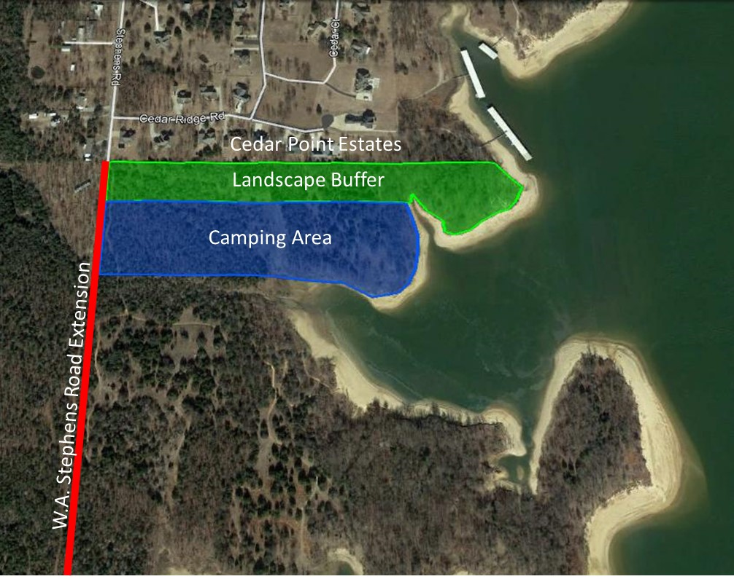

September 23, 2018

Dr. Joanne Chinnici, Mayor
Town of Carlton Landing
55 Boardwalk
Carlton Landing, OK 74432

Dear Mayor Chinnici,

As President of the Cedar Point Estates Home Owners Association, I wish to convey our neighborhood’s strong support of the extension of W.A. Stephens Road as described in Resolution No. 2018-02-50 by the Town of Carlton Landing.

Cedar Point Estates HOA supports this project for the following reasons:

- Improving Life Safety. We understand that the Town of Carlton Landing currently has only one means of ingress and egress and that road is prone to flooding. This poses obvious life safety concerns. We understand the Town’s need to provide safety and security to our citizens by providing another means of access and egress in cases of Emergency.

- Enhancing Public Recreation. Carlton Landing has been approved by the Corps of Engineers to create a new public marina with up to 300 boat slips. We see this new marina as a great public amenity which will enhance public access to recreational activities at the lake. We plan to enjoy and utilize the new amenities which are projected to include sports fields, recreational restaurants, retail and boating access.

Several neighbors in Cedar Point Estates, especially those who back up directly to Carlton Landing’s Leased Premises, have expressed concerns to me about the primitive camping within the Leased Premises. These concerns are primarily related to noise, safety, crime, and the risk of fire. On September 18th, your Town Manager, Grant Humphreys, met with me and a representative group of homeowners from Cedar Point Estates. We had a good discussion and where our concerns were voiced and we felt they were heard. Since that time, the Town of Carlton Landing has provided a reasonable compromise including the creation of a landscape buffer, a chain link fence, quiet hours and security patrol prior to the development of campsites adjacent to Cedar Point Estates. We view the Town’s commitment to incorporate these additions as a reasonable solution to our concerns.

Therefore, the Cedar Point Estates Home Owners Association stands with you in strong support of extending W.A. Stephens Road as requested. I hope that the County Commissioners of Pittsburg County will approve this request so that Carlton Landing can continue to move forward.

Sincerely,

Paul Dean, President
Cedar Point Estates Home Owners Association

